Instruction of change blue-shop

1. Login Master Saturn
2. 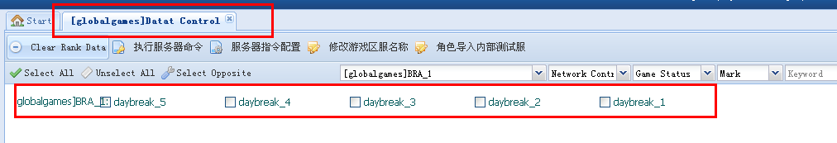
3. 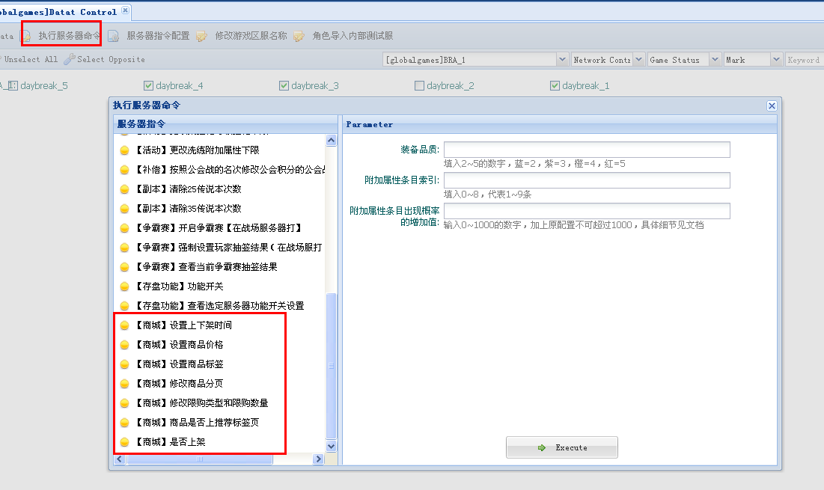
4. 【】设置上下架时间，means u can use this to control the time of items up and down from the shop .

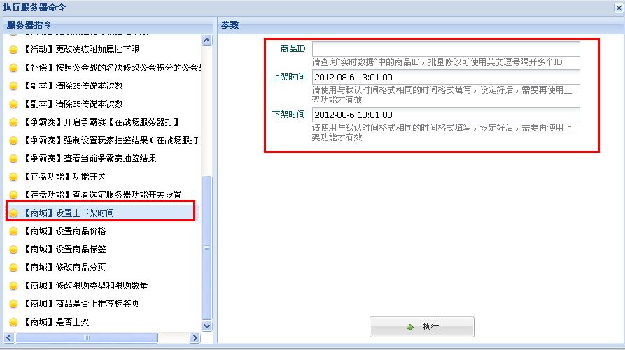

After u set this part, u need to do the last step to make item on shelf, then it will work.

1. [设置商品价格] this means to change the price of items.
2. [设置商品标签] this means to change the [HOT], [SALE] icon on item picture.

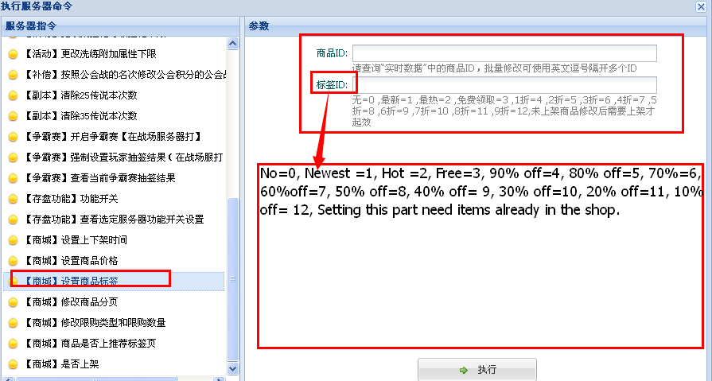

1. [修改商品分页] this means to change items in which page. like change stones to pet item page.

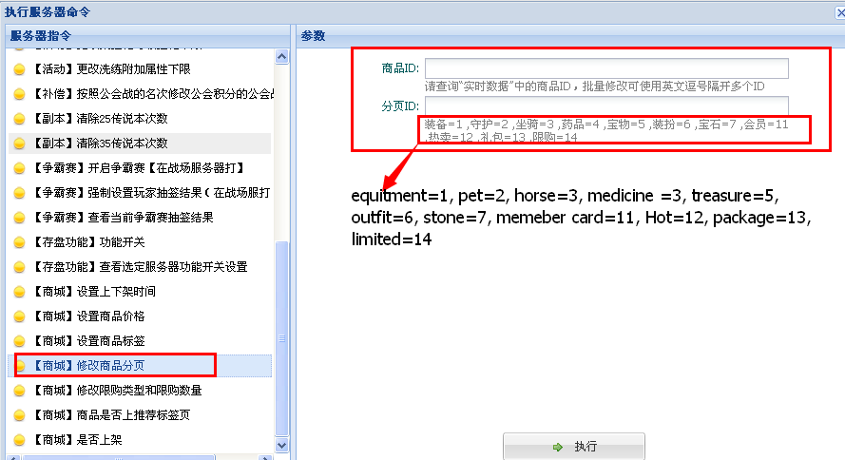

1. [修改限购类型和数量] this means to limited players to buy one item. Like one char can by only once or this item only sold 1000 in all servers.

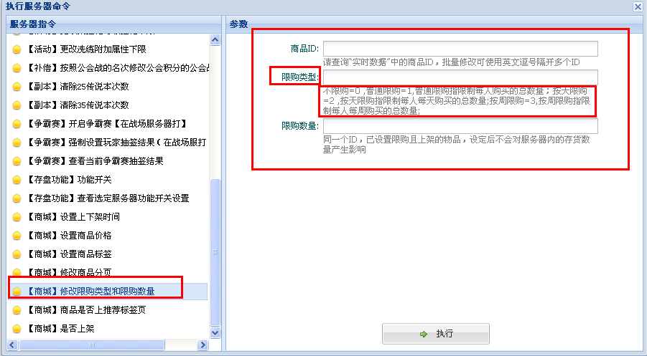

* 1. 限购类型：limited type：
  2. No limited=0,
  3. normal limited=1 (limited the amount for one char.),
  4. Daily limited=2(limited the daily amount per char.),
  5. weekly limited=3(limited the weekly amount per char.)

1. [商品是否上推荐标签页] this one is use to make the item on the recommend page

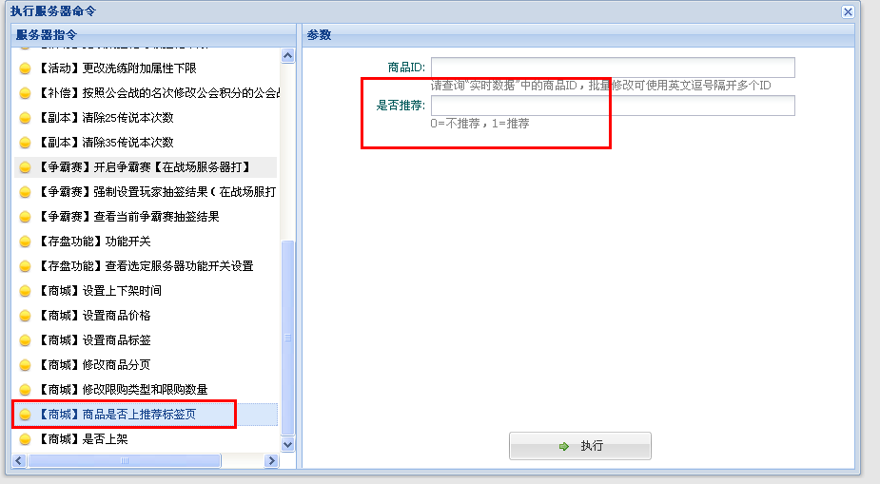

0= No recommend page, 1= put it on recommend page.

1. [是否上架] this one is used to take on /off the items from shop.

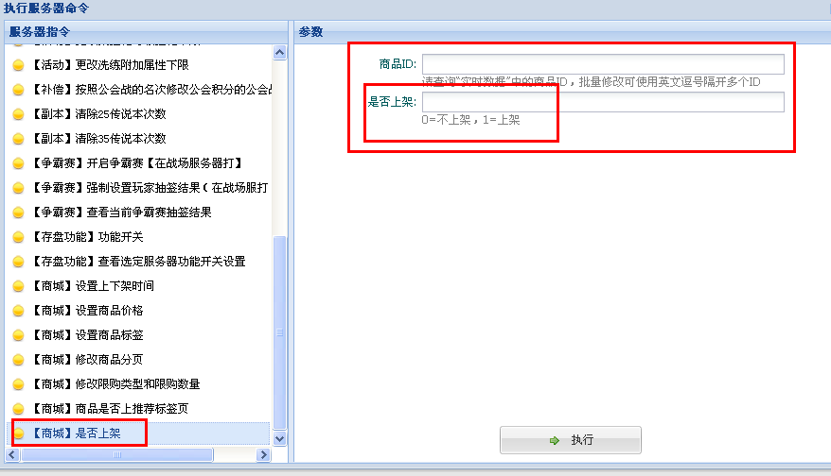

0= No shelf, 1= shelf

**About Item ID, U can find them by the Item ID I send to u which have 6 lines. And, please remember that u need to test this on test server to make sure its worked before u do it on live server.**